**1.What is Software Testing?**

**Software testing** is a process, to evaluate the functionality of a software application with an intent (विचार) to find whether the developed software met the specified requirements or not and to identify the defects to ensure that the product is defect-free to produce a quality product.

**2. What is the difference between SDET, Test Engineer and Developer?**

**Tester:**  
Tester is the person that performs the testing process on the software in order to detect the defects. Tester also checks different aspects of the software. Tester doesn’t know the development process of the software. Tester checks whether the software has bugs and defects or not.

**SDET:**  
SDET stands for Software Development Engineer in Test. SDET is the person that plays role in both development and testing process. SDET knows the internal design and implementation of the software. Tester who can code is known as SDET.

**Software Developer :**  
Software Developer, as name suggests, is person who is responsible for writing and maintaining source code of computer programming to develop software. It allows user to perform particular tasks on computer devices and also help in maintaining and updating programmer. He/she designs each and every piece of software and then plan how these pieces will work together to develop software.

|  |  |  |
| --- | --- | --- |
| Test Engineer | SDET | Developer |
| Test Engineer thinks only in the terms of pass or fail of a test case and how to break the software | SDET knows system functional objectives as well as quality objectives | Developer thinks how to develop a system and make a functionality work |
| Test Engineer works only for test life cycle, like design of test cases, and execution | SDET is involved in Designing, development, and testing | Developer is limited to Coding part and release to testing team |
| No coding knowledge is required | Dynamic skill sets, like knowledge of quality and testing and good in coding too | Only coding knowledge is required |
| Test Engineers know where repetitive work or simple data entry is present but they are not expected to minimize the repetitive tasks | SDET understands automation needs; they can code and provide a solution to the team where repetitive kind of work is killing the time. They can design framework which can help testing team to reduce repetitive test cycle or simple data entry task. | Developers don’t deal with such tasks |
| Test Engineers are not expected to reach up to code level and tune the performance | Well aware of Performance tuning and security threats , they can suggest and reach to the code and suggest where application is poor in performance, plus they can optimize the code | Developers are only expected to code the functionality which is expected by customer |

**3. What are the best practices for writing test cases?**

**What is a Test Case?**

Set of conditions or variables used by testers to determine whether a system works as expected are Test Cases. These help in validating the coverage of an application.

**A test case should be :**

* Easy to understand and execute
* Accurate
* Easy to trace as per requirements
* Repeatable
* Reusable

**Test cases include :**

Test cases include various fields which help in traceability of test as per the requirements. Following are the fields which are most likely to be a part of a test case :

1. **Test Case ID** – This is a unique ID for identification of a particular test case.
2. **Description** – This comprises of a brief detail about what is going to be tested.
3. **Pre-condition** – This includes any pre-requisite before moving towards the steps to test.
4. **Test Steps**– This includes a step-wise approach to test a particular test case.
5. **Expected** **Result** – This covers what should happen.
6. **Actual** **Result** – This encompasses of what actually happened.
7. **Status (Pass/Fail)** – This involves the status of a test case after performing a test, whether a test case was passed or failed.

**Best practices to write a test case :**

Test cases which are easy to execute are considered as good test cases. They make the testing process more efficient by saving time and effort. We can achieve this by following best practices :

**1) Keeping it Simple and Easy to Understand**

A good test case is the one which is easy to understand and execute for the testers. To be a good test case, it should be simple and organized category-wise. Different grouping techniques could be splitting the test cases based on user story or modules like browser specific behaviors etc. This makes it easy to review and maintain. Information given in the test cases should be clear to testers, developers and other stakeholders involved in the project.

**2) Including End User Perspective**

The [end user perspective](https://www.tothenew.com/experience-design) is a key element when it comes to maintaining the quality of software. Therefore, before drafting a test case, it’s important to think like an end user. Understanding the requirement and the functionality aspects covered by the end user’s perspective will help in identifying test scenarios that arise in real life business conditions.

**3) Using Correct Naming Conventions**

Naming the test cases in a way that makes it easy for stakeholders to identify as it will help create good and readable test cases. These also help in traceability as per requirements.

**4) Providing Test Case Description**

A proper test case description will allow users to understand what is being tested and how. Relevant details like the test environment, test data and tools to be used should also be provided.

**5) Including Assumptions**

All the assumptions and preconditions that are applicable to the test case should be specified clearly in the test case document.

**4. How many test cases you can execute in a day?**

**-**It depend on the project complicity .Normally 3-4 test cases I can execute in a day when these test cases are simple to write and execute.

**5.How many Test cases you can write in a day or how much time is required to write a test case?**

It takes about two to three days to build and review a simple test plan without test cases. Creating one test case usually takes **about 10-20 minutes**. The more test cases your product needs, the more time you should estimate for their development. However, not all projects require full test case coverage

**6. How many defects did you detect in your last project?**

**-**It depends on project means small project I will detect defect 3-5 defects per day but normally large scale project it takes the 2-3 day to detect defect**.**

**7. What is configuration management?**

Configuration management **determines clearly about the items that make up the software or system**. These items include source code, test scripts, third-party software, hardware, data and both development and test documentation.

**8.What are Quality Assurance and Quality Control?**

**Quality control** can be defined as "part of quality management focused on fulfilling quality requirements." While **Quality assurance** relates to how a process is performed or how a product is made, quality control is more the inspection aspect of quality management.

### Quality Assurance

### Quality assurance can be defined as "part of quality management focused on providing confidence that quality requirements will be fulfilled." The confidence provided by quality assurance is twofold—internally to management and externally to customers, government agencies, regulators, certifiers, and third parties. An alternate definition is "all the planned and systematic activities implemented within the quality system that can be demonstrated to provide confidence that a product or service will fulfil requirements for quality."

Examples of quality assurance activities include process checklists, process standards, process documentation and project audit.

**Examples of quality control** activities include inspection, deliverable peer reviews and the software testing process

**9.What is Verification in software testing?**

**Verification** is the process of evaluating work-products of a development phase to determine whether they meet the specified requirements.

**Verification** ensures that the product is built according to the requirements and design specifications. It also answers to the question, Are we building the product right?

**10.What is Validation in software testing?**

The process of evaluating software during the development process or at the end of the development process to determine whether it satisfies specified business requirements.

Validation Testing ensures that the product actually meets the client's needs. It can also be defined as to demonstrate that the product fulfils its intended use when deployed on appropriate environment.

It answers to the question, Are we building the right product?

**11.What is Static Testing? (Verification testing)**

**Static Testing** is a type of software testing in which software application is tested without code execution. Manual or automated reviews of code, requirement documents and document design are done in order to find the errors. The main objective of static testing is to improve the quality of software applications by finding errors in early stages of software development process.

Static testing involves manual or automated reviews of the documents. This review is done during an initial phase of testing to catch[Defect](https://www.guru99.com/defect-management-process.html)early in STLC. It examines work documents and provides review comments. It is also called Non-execution testing or verification testing.

**Static Testing Techniques:**

* **Informal Reviews:**This is one of the types of review which doesn’t follow any process to find errors in the document. Under this technique, you just review the document and give informal comments on it.
* **Technical Reviews:**A team consisting of your peers review the technical specification of the software product and checks whether it is suitable for the project. They try to find any discrepancies (difference) in the specifications and standards followed. This review concentrates mainly on the technical documentation related to the software such as Test Strategy,[Test Plan](https://www.guru99.com/what-everybody-ought-to-know-about-test-planing.html)and requirement specification documents.
* **Walkthrough:**The author of the work product explains the product to his team. Participants can ask questions if any.  A meeting is led by the author*.* Scribe makes note of review comments
* **Inspection:**The main purpose is to find defects and meeting is led by a trained moderator. This review is a formal type of review where it follows a strict process to find the defects. Reviewers have a checklist to review the work products. They record the defect and inform the participants to rectify those errors.
* **Static code Review:** This is a systematic review of the software source code without executing the code. It checks the syntax of the code, coding standards, code optimization, etc. This is also termed as white box testing. This review can be done at any point during development.

**12.What is Dynamic Testing?** (**Validation testing**.**)**

Under**Dynamic Testing**, a code is executed. It checks for functional behaviour of software system, memory/cpu usage and overall performance of the system. Hence the name “Dynamic”

The main objective of this testing is to confirm that the software product works in conformance with the business requirements. This testing is also called an Execution technique or validation testing.

Dynamic testing executes the software and validates the output with the expected outcome. Dynamic testing is performed at all levels of testing and it can be either black or white box testing.

## Dynamic Testing Techniques:

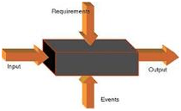

* **Unit Testing:** Under Unit Testing, individual units or modules are tested by the developers. It involves testing of source code by developers.
* **Integration Testing:**Individual modules are grouped together and tested by the developers. The purpose is to determine what modules are working as expected once they are integrated.
* **System Testing:**[System Testing](https://www.guru99.com/system-testing.html) is performed on the whole system by checking whether the system or application meets the requirement specification document.
* Also, Non-functional testing like performance, [Security Testing](https://www.guru99.com/what-is-security-testing.html) fall under the category of dynamic testing.
* **User Acceptance Testing** (UAT) is **a type of testing performed by the end user or the client to verify/accept the software system before moving the software application to the production environment**. UAT is done in the final phase of testing after functional, integration and system testing is done.
* **Types:**
* A[lpha Testing](https://www.geeksforgeeks.org/?p=294073) is a type of software testing performed to identify bugs before releasing the product to real users or to the public. Alpha Testing is one of the user acceptance testing.
* [Beta Testing](https://www.geeksforgeeks.org/?p=294134) is performed by real users of the software application in a real environment. Beta testing is one of the type of User Acceptance Testing.

Differ between Static and Dynamic Testing

|  |  |
| --- | --- |
| Static Testing | Dynamic Testing |
| Testing was done without executing the program | Testing is done by executing the program |
| This testing does the verification process | Dynamic testing does the validation process |
| Static testing is about prevention of defects | Dynamic testing is about finding and fixing the defects |
| Static testing gives an assessment of code and documentation | Dynamic testing gives bugs/bottlenecks in the software system. |
| Static testing involves a checklist and process to be followed | Dynamic testing involves test cases for execution |
| This testing can be performed before compilation | Dynamic testing is performed after compilation |
| Static testing covers the structural and statement coverage testing | Dynamic testing techniques are Boundary Value Analysis & Equivalence Partitioning. |
| Cost of finding defects and fixing is less | Cost of finding and fixing defects is high |
| Return on investment will be high as this process involved at an early stage | Return on investment will be low as this process involves after the development phase |
| More reviews  comments are highly recommended for good quality | More defects are highly recommended for good quality. |
| Requires loads of meetings | Comparatively requires lesser meetings |

**13.What is White Box Testing?**

White Box Testing is software testing technique in which internal structure, design and coding of software are tested to verify flow of input-output and to improve design, usability and security.

**14.What is Black Box Testing?**

Black box testing involves **testing a system with no prior knowledge of its internal workings**. A tester provides an input, and observes the output generated by the system under test.

**15.What is Positive and Negative Testing?**

**Positive testing**  :-It is used to check whether our application works as expected or not. And if an error is detected at the time of positive testing, the test is considered as fail. A positive testing is a technique whenever a test engineer writes the test cases for a set of respective outputs. In [positive testing](https://www.javatpoint.com/positive-testing), the test engineer will always check for only a good set of values. In other words, we can say that **positive testing** is a process where the system or an application is tested against the valid input data. And the primary purpose of performing the positive testing is to validate whether the software does what it is supposed to do.

In simple terms, we can say that positive testing is implemented by providing a **positive point of view.**

For example, **Numbers like 9999999.**

**Negative Testing:-** It is implemented to check how the application can gracefully handle invalid input or unpredicted user performance.

The fundamental purpose of executing the negative testing is to ensure the application's stability against the effects of different variations of improper validation data set.

[Negative testing](https://www.javatpoint.com/negative-testing) is also known as **error path testing or failure**. And it helps us to identify more bugs and enhance the quality of the software application under test.

Once the positive testing is complete, then only we can execute the negative testing, which helps to identify more bugs and enhance the quality of the software application under test.

We can say that the negative testing is executing by keeping the **negative point of view** in simple terms. For example, **99999abcde**

**16.What is Test Strategy?**

Test strategy is **a set of guidelines that explains test design and determines how testing needs to be done**. Components of Test plan include- Test plan id, features to be tested, test techniques, testing tasks, features pass or fail criteria, test deliverables, responsibilities, and schedule.

**17.What is Test Suite?**

A test suite is **a collection of test cases that are grouped for test execution purposes**.

**18.What is Test Case?**

The test case is defined as a group of conditions under which a tester determines whether a software application is working as per the customer's requirements or not. Test case designing includes preconditions, case name, input conditions, and expected result. A test case is a first level action and derived from test scenarios.

**19.What is Test Environment?**

A test environment consists of a space where software undergoes a series of experimental tests and uses. Test environments test specific parts of an application and require a different setup for all code parts. Having a well-defined test environment is critical because one that is weak will be riddled with bugs and errors.

Elements of a test environment include:

* the software to be tested
* software to interface between the system and applications
* test data
* the operating system, database, and testing server
* network configuration
* desktop or mobile device(s) on which the software is to be tested.

**20.What is Test Data?**

Test data to check all the boundary conditions includes **data which has all possible combinations of boundary values**. For example, if a text box can have number 2-20 then input 2 (minimum) and then 20 (maximum) values.

**21.What is Test Closure?**

Test Closure is **a document that gives a summary of all the tests conducted during the software development life cycle**, it also gives a detailed analysis of the bugs removed and errors found . In other words, Test Closure is a memo that is prepared prior to formally completing the testing process.

**22.What are the tasks of Test Closure activities in Software Testing?**

### I. Checking for completion of tests

Here the Test Manager ensures that every **test work has actually been completed**. For instance, each planned test must have been run or avoided deliberately.

All known bugs must be corrected, deferred, or acknowledged to be permanent limitations. In case of bug correction, the corrections must be tested as well.

### II. . Handing over test objects

The relevant **work products must be passed on to the relevant people**. For instance, known bugs must be conveyed to the system maintenance team.

Tests and its setup information must be conveyed to the maintenance testing team. Sets of manual as well as automated regression tests must be recorded and passed on to the system maintenance team.

### 3. Learning Experience

**document lessons learned** from the testing as well as the complete [**software** An important component of test closure activities is the meetings that **discuss and development life cycle**](http://tryqa.com/what-are-the-software-development-life-cycle-sdlc-phases/).

These discussions focus on ensuring that **good processes are repeated** and **poor ones are eliminated** in future. If some issues remain unresolved, they become part of project plans.

### 4. Archiving

**Test documents** like [**test reports**](http://tryqa.com/what-is-test-status-report-and-how-to-report-test-status/) and logs and work products **must be archived** in configuration management system.

Say, both test and project plans – with clear relationship with version and system used for testing – must be available in planning archive..

**23.What is test coverage?**

Test coverage is defined as **a technique which determines whether our test cases are actually covering the application code and how much code is exercised when we run those test cases**. If there are 10 requirements and 100 tests created and if 90 tests are executed then test coverage is 90%.

**24. List out Test Deliverables?**

Test Deliverables are the artifacts which mean “things” that are produced by people involved in the process and are given to the stakeholders. Some deliverables are provided before testing phase, some during the testing phase and rest after the testing cycle. The below are the list of test deliverables.

* Test Specifications document
* [Test Plan document](https://testnbug.com/2015/04/what-is-test-plan-in-software-testing-what-does-it-have-in-its-bag/)
* Test Strategy
* Test Scenarios document
* Test Design standards
* Test Case document
* Traceability matrix
* Test execution reports
* Test logs
* Bug reports
* Test summary reports
* Test Data
* Flow document
* Test Metrics
* Test Status reports.

**25.What are the most common components of a defect report?**

Defect Reporting will have several common components in every tool:

1. Defect Title

2. Defect Description

3. Assigned to

1. Priority
2. Severity
3. Found in release
4. Resolution status
5. Created by
6. Attachment etc.
7. Project ID

Apart from these some optional fields are there.

Project name, Country, reporting date, release version etc.

**26.What are the levels of testing?**

There are generally four recognized levels of testing:

**I. Unit/component testing,**

**II.Integration testing,**

**III.system testing,**

**IV. acceptance testing**.

**27.What is Integration Testing?**

It is mainly used to test the **data flow from one module or component to other modules.**

In integration testing, the **test engineer** tests the units or separate components or modules of the software in a group. The primary purpose of executing the integration testing is to identify the defects at the interaction between integrated components or units. **When each component or module works separately, we need to check the data flow between the dependent modules, and this process is known as integration testing**. We only go for the integration testing when the functional testing has been completed successfully on each application module. In simple words, we can say that **integration testing** aims to evaluate the accuracy of communication among all the modules.

**28.What is the difference between integration testing and system testing?**

System testing is a testing level in which tests are performed to know if a complete build aligns with functional and non-functional requirements made for it.

In contrast, Integration testing is a testing stage where two or more software units are joined and tested simultaneously.

|  |  |  |  |
| --- | --- | --- | --- |
| S.No. | Comparison | System Testing | Integration Testing |
| 1. | Basic | Tests the finished product. | Validates the collection and interface modules. |
| 2. | Performed | After integration testing | After unit testing |
| 3. | Requires | Understanding of the internal structure and programming language. | Knowledge of just interlinked modules and their interaction. |
| 4. | Emphasis | On the behaviour of all module as a whole. | System functionalities interface between individual modules. |
| 5. | Covers | Functional as well as non-functional tests. | Only functional testing. |

**29.What is End-To-End Testing?**

**End-to-end testing is a methodology** used in the software development lifecycle (SDLC) to test the functionality and performance of an application under product-like circumstances and data to replicate live settings. **The goal**is to simulate what a real user scenario looks like from start to finish. The completion of this testing is not only to validate the system under test, but to also ensure that its sub-systems work and behave as expected.

**30.What is Functional Testing?**

**FUNCTIONAL TESTING** is a type of software testing that validates the software system against the functional requirements/specifications. The purpose of Functional tests is to test each function of the software application, by providing appropriate input, verifying the output against the Functional requirements.

**31.What is Non-Functional Testing?**

**NON-FUNCTIONAL TESTING** is defined as a type of Software testing to check non-functional aspects (performance, usability, reliability, etc.) of a software application. It is designed to test the readiness of a system as per non-functional parameters which are never addressed by functional testing.

**32.What is Acceptance Testing?**

This is **a type of testing done by users, customers, or other authorised entities to determine application/software needs and business processes**.

Description: Acceptance testing is the most important phase of testing as this decides whether the client approves the application/software or not.

**Types: Alpha and beta testing** are examples of acceptance testing. Alpha tests are internal and aim to spot any glaring defects, while beta testing is an external pilot-test of a product before it goes into commercial production.

**33 and 34.What is Smoke & Sanity Testing?**

**Smoke Testing** **is a software testing technique performed post software build to verify that the critical functionalities of software are working fine**. It is executed before any detailed functional or regression tests are executed. The main purpose of smoke testing is to reject a software application with defects so that QA team does not waste time testing broken software application.

**Sanity Testing** **is a kind of Software Testing performed after receiving a software build, with minor changes in code, or functionality,** to ascertain that the bugs have been fixed and no further issues are introduced due to these changes. The goal is to determine that the proposed functionality works roughly as expected. If sanity test fails, the build is rejected to save the time and costs involved in a more rigorous testing.

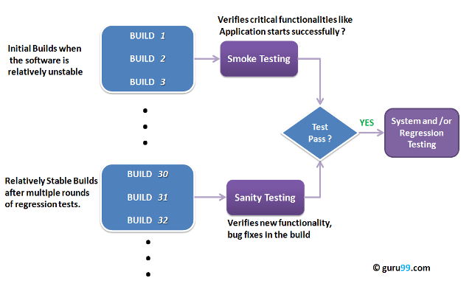

## 35.What is Smoke Testing Vs Sanity Testing – Key Differences

|  |  |
| --- | --- |
| Smoke Testing | Sanity Testing |
| Smoke Testing is performed to as certain that the critical functionalities of the program is working fine | Sanity Testing is done to check the new functionality/bugs have been fixed |
| The objective of this testing is to verify the “stability” of the system in order to proceed with more rigorous testing | The objective of the testing is to verify the “rationality” of the system in order to proceed with more rigorous testing |
| This testing is performed by the developers or testers | Sanity testing in software testing is usually performed by testers |
| Smoke testing is usually documented or scripted | Sanity testing is usually not documented and is unscripted |
| Smoke testing is a subset of Acceptance testing | Sanity testing is a subset of [Regression Testing](https://www.guru99.com/regression-testing.html) |
| Smoke testing exercises the entire system from end to end | Sanity testing exercises only the particular component of the entire system |
| Smoke testing is like General Health Check Up | Sanity Testing is like specialized health check up |

**36. What is Retesting?**

Retesting is **a procedure where we need to check that particular test cases which are found with some bugs during the execution time**. Retesting also occurs when the product is already tested and due to some problems it needs to be tested again. This test is named as retesting.

**37.What is Regression Testing**?

Regression testing is **a software testing practice that ensures an application still functions as expected after any code changes, updates, or improvements**. Regression testing is responsible for the overall stability and functionality of the existing features.

**38.What is Installation Testing?**

**Installation testing** is check that software application is successfully installed & it is working as expected after installation. This is testing phase prior to end users will firstly interact with the actual application. [Installation testing](https://www.softwaretestingclass.com/what-isinstallation-testing/) is also called as “Implementation Testing”. This is most important as well as most interesting step in the Software testing life cycle.

**39.What is Exploratory Testing?**

* Exploratory testing is a hands-on approach in which testers are involved in **minimum planning** and maximum test execution.
* The [**test planning**](http://tryqa.com/what-is-test-planning-what-are-work-products-in-testing/) involves the creation of a test charter, a short declaration of the scope of a short (1 to 2 hour) time-boxed test effort, the objectives and possible approaches to be used.

**40.What is Adhoc Testing?**

**Ad hoc Testing** is an informal or unstructured software testing type that aims to break the testing process in order to find possible defects or errors at an early possible stage. Ad hoc testing is done randomly and it is usually an unplanned activity which does not follow any documentation and test design techniques to create test cases.

**41.What is a Defect?**

Something or a lack of something that results in incompleteness, inadequacy, or imperfection.

**42.What is a Bug?**

A software bug is an error, flaw or fault in computer software that causes it to produce an incorrect or unexpected result,

**43.What is an Error?**

An error is an action which is inaccurate or incorrect.

An Error is a mistake made in the code; that's why we cannot execute or compile code.

**44.What is a Failure?**

 A failure that occurs when the user perceives that the software has ceased to deliver the expected result with respect to the specification input values.

**45.What is Bug Severity**?

Bug severity is **the measure of impact a defect (or bug) can have on the development or functioning of an application feature when it is being used**. It depends on the effect of the bug on the system.

**46.What is Bug Priority?**

Bug priority is **a way to decide in what order the defects will be fixed**. The higher the priority is, the sooner a development team is going to look into the problem. Very often, bug priority is determined by its severity.

**47.Tell some examples of Bug Severity and Bug Priority ?**

|  |  |
| --- | --- |
| **Bug Severity** | **Bug Priority** |
| High severity and low priority status means that the bug can cause significant damage, but can be fixed at a later date | High priority and low severity status means that the bug must be fixed immediately but it does not affect the software too adversely |

**Examples**

**High Priority, Low Severity bug :-** If the company name is misspelled in the home page of the website,then the priority is high and severity is low to fix it.

**High Severity, Low Priority :-** Web page not found when user clicks on a link (user&#39;s does not visit that page generally)

**Low Priority, Low Severity :-** Any cosmetic or spelling issues which is within a paragraph or in the report

**High Priority, High Severity :-** An error which occurs on the basic functionality of the application and will not allow the user to use the system (E.g. user is not able to login to the application)

**48.What is a Critical Bug?**

Critical defects usually block an entire system's or module's functionality, and testing cannot proceed further without such a defect being fixed.

**49.What is Bug Life Cycle?**

Bug life cycle also known as defect life cycle is **a process in which defect goes through different stages in its entire life**. This lifecycle starts as soon as a bug is reported by the tester and ends when a tester ensures that the issue is fixed and won't occur again.

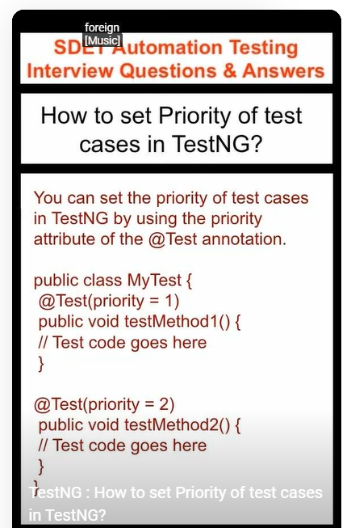

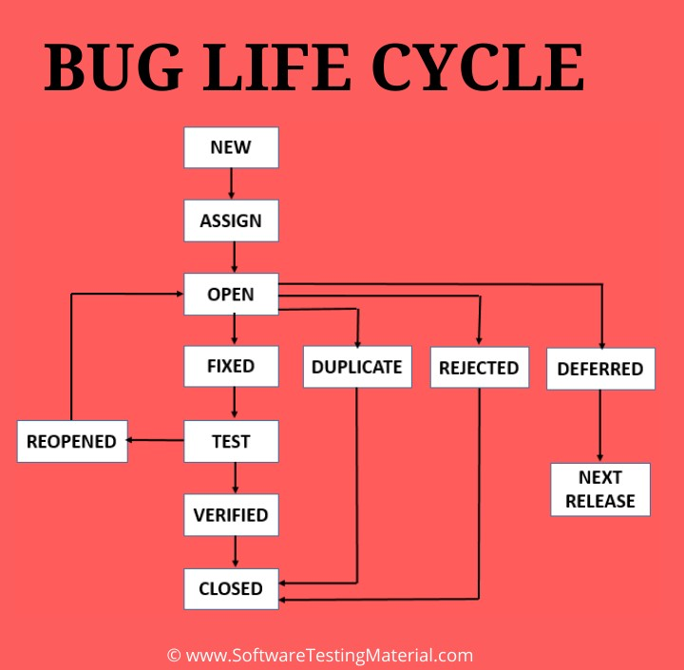

**50.What are the different stages in a defect life cycle?**

* **New -**Potential defect that is raised and yet to be validated.
* **Assigned -**Assigned against a development team to address it but not yet resolved.
* **Active -**The Defect is being addressed by the developer and investigation is under progress. At this stage there is two possible outcomes; viz - Deferred or Rejected.
* **Test -**The Defect is fixed and ready for testing.
* **Verified -**The Defect that is retested and the test has been verified by QA.
* **Closed -**The final state of the defect that can be closed after the QA retesting or can be closed if the defect is duplicate or considered as NOT a defect.
* **Reopened -**When the defect is NOT fixed, QA reopens/reactivates the defect.
* **Deferred -**When a defect cannot be addressed in that particular cycle it is deferred to future release.
* **Rejected -**A defect can be rejected for any of the 3 reasons; viz - duplicate defect, NOT a Defect, Non Reproducible.

**51.What is HotFix?**

Hotfixes are also known as QFE updates, short for **quick-fix engineering updates**, a name that illustrates the urgency. Normally, you'll create a hotfix quickly, as an urgent measure against issues that need to be fixed immediately and outside of your normal development flow.

**52.What is STLC (Software Testing Lifecycle)?**

The Software Testing Life Cycle (STLC) is a sequence of specific actions performed during the testing process to ensure that the software quality objectives are met. The STLC includes both verification and validation. Contrary to popular belief, software testing is not just a separate activity. It consists of a series of methodological activities to help certify your software product.

1. Requirements analysis;
2. Planning;
3. Engineering and design;
4. Software development;
5. Testing;
6. Deployment.

**53.What are the stages in the software testing lifecycle?**

**1. Requirement analysis**

Most development initiatives begin with software requirements that specify what the business expects from the project. Software requirements often include high-level business needs, architectural requirements that detail how the feature will be designed and supported, and detailed system requirements from which developers build the product. System requirements include functional and non-functional specifications, both of which present opportunities to test and validate.

In this STLC phase, testers work both within their own teams and cross-functionally to contextualize how they will test the software. Requirement analysis often includes brainstorming sessions, identifying blind spots or unclear areas in the requirements, and prioritizing certain assessments.

When in doubt or lacking requirements documentation, the QA team will question the engineering or business side to clarify and calcify a testing strategy.

**2. Test planning**

The second STLC phase is important, as it guides much of the work to follow. Test planning takes the insights found during requirements or product analysis and turns them into a documented QA strategy.

The test team leadership determines what resources and efforts will evaluate the release. The resulting test plan documentation both informs testers and other departments how the testing work will commence, keeping everyone on the same page. This plan is especially helpful if other members of the organization will take part in testing and bug remediation, such as developers executing unit tests and writing hotfixes.

The test plan spells out several details of the QA work to be done, including the scope, objectives, types of functional and non-functional tests (both automated and manual), and details for the test environments. Once these details are determined, [test management](https://www.applause.com/blog/test-case-management-key-to-exceptional-qa) sets roles and timelines for the work. Finally, the testing team can determine what deliverables it will provide upon completion of the STLC phases.

**3. Test case design and development**

With the test plan in place, testers can begin to write and create detailed test cases. In this STLC phase, the QA team fleshes out the details of the structured tests they will run, including any test data they will need to facilitate those tests. While tests must ultimately validate the areas defined by requirements, testers can exert their skills and creativity in how they achieve this task.

When conceptualizing test cases, the tester’s goal should be to validate functionality within the allotted time and scope, especially core functionality. Test cases should be simple and well understood for any member of the team, but also unique from other test cases. Test cases should aim to achieve full coverage of the requirements in the specifications document — a traceability matrix can help track coverage. It’s important that test cases be identifiable and repeatable, as developers will add new functionality to the product over time, requiring tests to run again. They must also not alter the test environment for future tests, especially when validating configurations.

[Test cases might also require maintenance](https://www.applause.com/blog/now-is-the-time-for-test-suite-maintenance) or updates over time to validate both new and existing functionality. This work also occurs at this STLC stage.

Once test cases are ready, a test team lead or peer can review them. They might also review and update automated test scripts at this STLC stage. Ultimately, the team prioritizes and organizes these test cases into test suites that run later.

**4. Test environment setup**

The test environment provides the setting where the actual testing occurs. This is a crucial software testing life cycle phase, and it requires help from other members of the organization. Testers must have access to bug reporting capabilities, as well as the application architecture to support the product. Without these elements, testers might not be able to do their jobs.

Once ready, testers establish the [parameters for the test environment](https://www.applause.com/blog/whats-missing-in-your-testing-environment), which include the hardware, software, test data, frameworks, configurations and network. In this STLC phase, testers adjust these environment parameters depending on what the test case requires. For example, the majority of a product’s users might be on an Android device, use a certain version of a Chrome browser and have a certain amount of processing power on those devices — these are parameters the test environment would include.

Smoke tests within these test environments provide a very early and rudimentary check that the software is ready for more comprehensive testing. These smoke tests against the builds are part of the deliverable in this STLC phase.

**5. Test execution**

Next in the software testing life cycle, it’s time to fully test the product. At this STLC stage, testers execute all of the test cases, or as many as is possible within the allotted time. QA professionals and automated scripts execute a number of functional and non-functional tests.

Here in the STLC, testers will identify and [report detailed bugs](https://www.applause.com/blog/write-an-impactful-bug-report) that arise from test case execution and log the system’s performance compared to its requirements. As developers make fixes, testers often retest the product to make sure new defects don’t materialize. With all of these tests piling up in the test execution STLC phase, it’s important to make use of test automation where possible to achieve the test coverage and velocity you need.

**6. Test cycle closure**

The final STLC phase is test cycle closure. In this stage, the testing team provides a test closure report, which summarizes and communicates its findings with the rest of the team. This report typically includes summaries of the testing work and results, an assessment of the testing and the manager’s approval.

During the test cycle closure, the testing team checks its deliverables, which include details relevant to the testing work, such as the test strategy, test case documents, automated test scripts and test results. The team will then complete and close incident reports, which detail unusual or unexpected behavior that the test team observes during testing. The team must also archive the resources it used during testing, such as scripts, tools and environments, for later use.

From there, the organization plans the product [for support and release](https://go.applause.com/how-expensify-achieves-high-quality-daily-releases-watch-now.html?mc=null&ls=null&lc=null&cc=null&orig_mc=null&orig_ls=null&orig_lc=null&orig_cc=null&utm_campaign=null&utm_medium=null&utm_source=null&orig_utm_campaign=null&orig_utm_medium=null&orig_utm_source=null&gclid=null), which often includes acceptance and feedback from customer representatives.

Communication is key in this STLC phase, as additional perspectives might uncover a quality, cost or coverage issue that the rest of the group missed. These discussions can yield additional analysis or inform how to improve QA work in the future.

**54.When to stop testing? (Or) How do you decide when you have tested enough?**

It is difficult to determine when to stop testing, as testing is a never-ending process and no one can claim that a software is 100% tested. The following aspects are to be considered for stopping the testing process −

* Testing Deadlines
* Completion of test case execution
* Completion of functional and code coverage to a certain point
* Bug rate falls below a certain level and no high-priority bugs are identified
* Management decision.

## STLC vs SDLC: How Do They Differ?

Although both are related to software development, with overlapping timelines, Software Development Life Cycle and Software Testing Life Cycle follow different goals and guidelines. STLC can be performed as a series of steps within the SDLC cycle or can be performed alongside SDLC phases.

The primary difference is that SDLC is responsible for collecting requirements and creating features accordingly. Meanwhile, STLC is responsible for creating tests adapted to the collected requirements and for verifying that features meet those requirements. If the SDLC created features that do more than necessary, it’s often okay, however, if STLC tests do more than necessary an unnecessary burden is placed on the team.

Both life cycles require the cooperation of stakeholders, DevOps, and testing teams. Without this cooperation, you cannot verify that requirements are properly defined, that tests are relevant, or that results are applied properly.

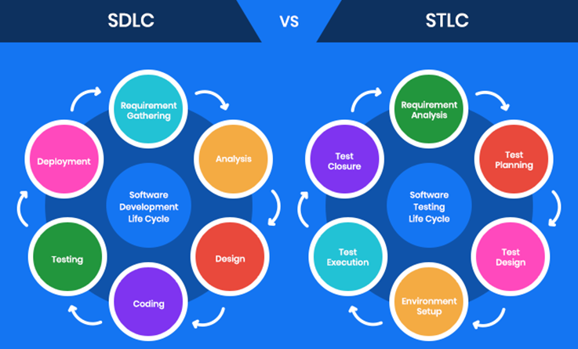

Source: [Goodcore](https://www.goodcore.co.uk/blog/software-testing-life-cycle/)

## The 6 STLC Phases In-Depth

Software Testing Life Cycle  consists of 6 phases, each with defined entry and exit criteria and associated activities and deliverables. Entry and exit criteria define when a phase can start and when it can end. Activities and deliverables define what actions are performed and what the expected result is. Some of these phases can be performed simultaneously while others require previous phases to be completed first.

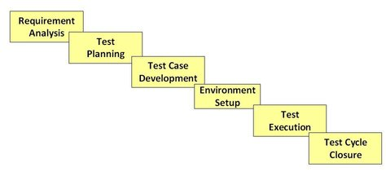

Source: [guru99](https://www.guru99.com/software-testing-life-cycle.html)

### Phase 1: Requirement Analysis

During this phase, feature requirements collected in the SDLC process are evaluated to identify testable aspects. If necessary, testing teams may need to consult with stakeholders to clarify requirements. These requirements can either be functional or non-functional, defining what a feature can do or it’s characteristics respectively. The ability to [automate testing](https://www.sealights.io/blog/best-practices-in-automated-regression-testing/) is also evaluated during this phase.

* **Entry Criteria**—documented requirements, acceptance criteria, and intended product architecture.
* **Exit Criteria**—approved requirement traceability matrix (RTM) and automation feasibility report.

### Phase 2: Test Planning

During this phase, the test strategy is outlined in a test plan document. This strategy includes tools needed, testing steps, and roles and responsibilities. Part of determining this strategy is a risk and cost analysis and an estimated timeline for testing.

* **Entry Criteria**—requirement analysis, RTM, and automation feasibility report.
* **Exit Criteria**—approved test plan including timelines and risk/cost analysis.

### Phase 3: Test Case Development

During this phase, test cases are created. Each case defines test inputs, procedures, execution conditions, and anticipated results. Test cases should be transparent, efficient, and adaptable. Once all test cases are created, test coverage should be 100%. Any necessary automation scripts are also created during this phase.

* **Entry Criteria**—approved test plan including timelines and risk/cost analysis.
* **Exit Criteria**—approved test cases and automation scripts.

### Phase 4: Test Environment Setup

During this phase, testing environments are configured and deployed. This phase may include a variety of testing tools, including Test Complete, Selenium, Appium, or Katalon Studio. Sometimes, this phase also includes setting up test servers. Once environments are deployed, smoke tests are performed to ensure that environments are working as expected with all intended functionality.

* **Entry Criteria**: system design and project architecture definitions.
* **Exit Criteria**: a fully functional test environment and approved test cases.

### Phase 5: Test Execution

During this phase, features are tested in the deployed environment, using the established test cases. Expected test results are compared to actual and results are gathered to report back to development teams.

* **Entry Criteria—**all exit criteria from previous steps.
* **Exit Criteria**—all tests are performed and results are documented.

### Phase 6: Test Cycle Closure

This is the last phase of the STLC, during which a test result report is prepared. This report should summarize the entire testing process and provide comparisons between expected results and actual. These comparisons include objectives met, time taken, total costs, test coverage, and any defects found.

* **Entry Criteria**—test results and logging from all previous phases.
* **Exit Criteria**—delivered and approved test closure report.



**Explain Sdlc.**

The following figure is a graphical representation of the various stages of a typical SDLC.

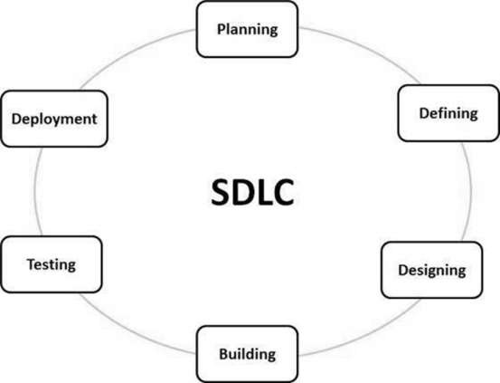

A typical Software Development Life Cycle consists of the following stages −

### Stage 1: Planning and Requirement Analysis

Requirement analysis is the most important and fundamental stage in SDLC. It is performed by the senior members of the team with inputs from the customer, the sales department, market surveys and domain experts in the industry. This information is then used to plan the basic project approach and to conduct product feasibility study in the economical, operational and technical areas.

Planning for the quality assurance requirements and identification of the risks associated with the project is also done in the planning stage. The outcome of the technical feasibility study is to define the various technical approaches that can be followed to implement the project successfully with minimum risks.

### Stage 2: Defining Requirements

Once the requirement analysis is done the next step is to clearly define and document the product requirements and get them approved from the customer or the market analysts. This is done through an **SRS (Software Requirement Specification)** document which consists of all the product requirements to be designed and developed during the project life cycle.

### Stage 3: Designing the Product Architecture

SRS is the reference for product architects to come out with the best architecture for the product to be developed. Based on the requirements specified in SRS, usually more than one design approach for the product architecture is proposed and documented in a DDS - Design Document Specification.

This DDS is reviewed by all the important stakeholders and based on various parameters as risk assessment, product robustness, design modularity, budget and time constraints, the best design approach is selected for the product.

A design approach clearly defines all the architectural modules of the product along with its communication and data flow representation with the external and third party modules (if any). The internal design of all the modules of the proposed architecture should be clearly defined with the minutest of the details in DDS.

### Stage 4: Building or Developing the Product

In this stage of SDLC the actual development starts and the product is built. The programming code is generated as per DDS during this stage. If the design is performed in a detailed and organized manner, code generation can be accomplished without much hassle.

Developers must follow the coding guidelines defined by their organization and programming tools like compilers, interpreters, debuggers, etc. are used to generate the code. Different high level programming languages such as C, C++, Pascal, Java and PHP are used for coding. The programming language is chosen with respect to the type of software being developed.

### Stage 5: Testing the Product

This stage is usually a subset of all the stages as in the modern SDLC models, the testing activities are mostly involved in all the stages of SDLC. However, this stage refers to the testing only stage of the product where product defects are reported, tracked, fixed and retested, until the product reaches the quality standards defined in the SRS.

### Stage 6: Deployment in the Market and Maintenance

Once the product is tested and ready to be deployed it is released formally in the appropriate market. Sometimes product deployment happens in stages as per the business strategy of that organization. The product may first be released in a limited segment and tested in the real business environment (UAT- User acceptance testing).

Then based on the feedback, the product may be released as it is or with suggested enhancements in the targeting market segment. After the product is released in the market, its maintenance is done for the existing customer base.

**OR ( JAVATPOINT)**

SDLC Cycle represents the process of developing software. SDLC framework includes the following steps:

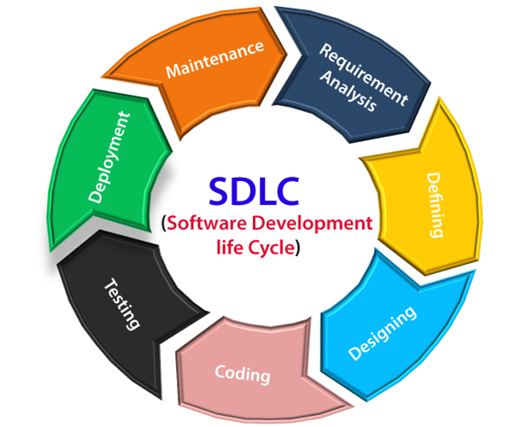

## The stages of SDLC are as follows:

**Stage1: Planning and requirement analysis**

Requirement Analysis is the most important and necessary stage in SDLC.

The senior members of the team perform it with inputs from all the stakeholders and domain experts or SMEs in the industry.

Planning for the quality assurance requirements and identifications of the risks associated with the projects is also done at this stage.

Business analyst and Project organizer set up a meeting with the client to gather all the data like what the customer wants to build, who will be the end user, what is the objective of the product. Before creating a product, a core understanding or knowledge of the product is very necessary.

**For Example**, A client wants to have an application which concerns money transactions. In this method, the requirement has to be precise like what kind of operations will be done, how it will be done, in which currency it will be done, etc.

Once the required function is done, an analysis is complete with auditing the feasibility of the growth of a product. In case of any ambiguity, a signal is set up for further discussion.

Once the requirement is understood, the SRS (Software Requirement Specification) document is created. The developers should thoroughly follow this document and also should be reviewed by the customer for future reference.

**Stage2: Defining Requirements**

Once the requirement analysis is done, the next stage is to certainly represent and document the software requirements and get them accepted from the project stakeholders.

This is accomplished through "SRS"- Software Requirement Specification document which contains all the product requirements to be constructed and developed during the project life cycle.

**Stage3: Designing the Software**

The next phase is about to bring down all the knowledge of requirements, analysis, and design of the software project. This phase is the product of the last two, like inputs from the customer and requirement gathering.

**Stage4: Developing the project**

In this phase of SDLC, the actual development begins, and the programming is built. The implementation of design begins concerning writing code. Developers have to follow the coding guidelines described by their management and programming tools like compilers, interpreters, debuggers, etc. are used to develop and implement the code.

**Stage5: Testing**

After the code is generated, it is tested against the requirements to make sure that the products are solving the needs addressed and gathered during the requirements stage.

During this stage, unit testing, integration testing, system testing, acceptance testing are done.

**Stage6: Deployment**

Once the software is certified, and no bugs or errors are stated, then it is deployed.

Then based on the assessment, the software may be released as it is or with suggested enhancement in the object segment.

After the software is deployed, then its maintenance begins.

**Stage7: Maintenance**

Once when the client starts using the developed systems, then the real issues come up and requirements to be solved from time to time.

This procedure where the care is taken for the developed product is known as maintenance.

**GURU99**

## SDLC Phases

The entire SDLC process divided into the following SDLC steps:



SDLC Phases

* Phase 1: Requirement collection and analysis
* Phase 2: Feasibility study
* Phase 3: Design
* Phase 4: Coding
* Phase 5: Testing
* Phase 6: Installation/Deployment
* Phase 7: Maintenance

In this tutorial, I have explained all these Software Development Life Cycle Phases

### Phase 1: Requirement collection and analysis

The requirement is the first stage in the SDLC process. It is conducted by the senior team members with inputs from all the stakeholders and domain experts in the industry. Planning for the [quality assurance](https://www.guru99.com/all-about-quality-assurance.html) requirements and recognization of the risks involved is also done at this stage.

This stage gives a clearer picture of the scope of the entire project and the anticipated issues, opportunities, and directives which triggered the project.

Requirements Gathering stage need teams to get detailed and precise requirements. This helps companies to finalize the necessary timeline to finish the work of that system.

### Phase 2: Feasibility study

Once the requirement analysis phase is completed the next sdlc step is to define and document software needs. This process conducted with the help of ‘Software Requirement Specification’ document also known as ‘SRS’ document. It includes everything which should be designed and developed during the project life cycle.

**There are mainly five types of feasibilities checks:**

* **Economic:**Can we complete the project within the budget or not?
* **Legal:** Can we handle this project as cyber law and other regulatory framework/compliances.
* **Operation feasibility:** Can we create operations which is expected by the client?
* **Technical:** Need to check whether the current computer system can support the software
* **Schedule:** Decide that the project can be completed within the given schedule or not.

### Phase 3: Design

In this third phase, the system and software design documents are prepared as per the requirement specification document. This helps define overall system architecture.

This design phase serves as input for the next phase of the model.

There are two kinds of design documents developed in this phase:

**High-Level Design (HLD)**

* Brief description and name of each module
* An outline about the functionality of every module
* Interface relationship and dependencies between modules
* Database tables identified along with their key elements
* Complete architecture diagrams along with technology details

**Low-Level Design (LLD)**

* Functional logic of the modules
* Database tables, which include type and size
* Complete detail of the interface
* Addresses all types of dependency issues
* Listing of error messages
* Complete input and outputs for every module

### Phase 4: Coding

Once the system design phase is over, the next phase is coding. In this phase, developers start build the entire system by writing code using the chosen programming language. In the coding phase, tasks are divided into units or modules and assigned to the various developers. It is the longest phase of the Software Development Life Cycle process.

In this phase, Developer needs to follow certain predefined coding guidelines. They also need to use [programming tools](https://www.guru99.com/software-development-tools.html) like compiler, interpreters, debugger to generate and implement the code.

### Phase 5: Testing

Once the software is complete, and it is deployed in the testing environment. The testing team starts testing the functionality of the entire system. This is done to verify that the entire application works according to the customer requirement.

During this phase, QA and testing team may find some bugs/defects which they communicate to developers. The development team fixes the bug and send back to QA for a re-test. This process continues until the software is bug-free, stable, and working according to the business needs of that system.

### Phase 6: Installation/Deployment

Once the software testing phase is over and no bugs or errors left in the system then the final deployment process starts. Based on the feedback given by the project manager, the final software is released and checked for deployment issues if any.

### Phase 7: Maintenance

Once the system is deployed, and customers start using the developed system, following 3 activities occur

* Bug fixing – bugs are reported because of some scenarios which are not tested at all
* Upgrade – Upgrading the application to the newer versions of the Software
* Enhancement – Adding some new features into the existing software

The main focus of this SDLC phase is to ensure that needs continue to be met and that the system continues to perform as per the specification mentioned in the first phase.

## Popular SDLC Models

Here, are some of the most important models of Software Development Life Cycle (SDLC):

### [Waterfall model in SDLC](https://www.guru99.com/what-is-sdlc-or-waterfall-model.html)

The waterfall is a widely accepted SDLC model. In this approach, the whole process of the software development is divided into various phases of SDLC. In this SDLC model, the outcome of one phase acts as the input for the next phase.

This SDLC model is documentation-intensive, with earlier phases documenting what need be performed in the subsequent phases.

### [Incremental Model in SDLC](https://www.guru99.com/what-is-incremental-model-in-sdlc-advantages-disadvantages.html)

The incremental model is not a separate model. It is essentially a series of waterfall cycles. The requirements are divided into groups at the start of the project. For each group, the SDLC model is followed to develop software. The SDLC life cycle process is repeated, with each release adding more functionality until all requirements are met. In this method, every cycle act as the maintenance phase for the previous software release. Modification to the incremental model allows development cycles to overlap. After that subsequent cycle may begin before the previous cycle is complete.

### [V-Model in SDLC](https://www.guru99.com/v-model-software-testing.html)

In this type of SDLC model testing and the development, the phase is planned in parallel. So, there are verification phases of SDLC on the side and the validation phase on the other side. V-Model joins by Coding phase.

### [Agile Model in SDLC](https://www.guru99.com/agile-scrum-extreme-testing.html)

Agile methodology is a practice which promotes continue interaction of development and testing during the SDLC process of any project. In the Agile method, the entire project is divided into small incremental builds. All of these builds are provided in iterations, and each iteration lasts from one to three weeks.

### [Spiral Model](https://www.guru99.com/what-is-spiral-model-when-to-use-advantages-disadvantages.html)

The spiral model is a risk-driven process model. This SDLC testing model helps the team to adopt elements of one or more process models like a waterfall, incremental, waterfall, etc.

This model adopts the best features of the prototyping model and the waterfall model. The spiral methodology is a combination of rapid prototyping and concurrency in design and development activities.

### Big bang model

Big bang model is focusing on all types of resources in software development and coding, with no or very little planning. The requirements are understood and implemented when they come.

This model works best for small projects with smaller size development team which are working together. It is also useful for academic software development projects. It is an ideal model where requirements is either unknown or final release date is not given.

## Summary

* The Software Development Life Cycle (SDLC) is a systematic process for building software that ensures the quality and correctness of the software built
* The full form SDLC is Software Development Life Cycle or Systems Development Life Cycle.
* SDLC in software engineering provides a framework for a standard set of activities and deliverables
* Seven different SDLC stages are 1) Requirement collection and analysis 2) Feasibility study: 3) Design 4) Coding 5) Testing: 6) Installation/Deployment and 7) Maintenance
* The senior team members conduct the [requirement analysis](https://www.guru99.com/learn-software-requirements-analysis-with-case-study.html) phase
* Feasibility Study stage includes everything which should be designed and developed during the project life cycle
* In the Design phase, the system and software design documents are prepared as per the requirement specification document
* In the coding phase, developers start build the entire system by writing code using the chosen programming language
* Testing is the next phase which is conducted to verify that the entire application works according to the customer requirement.
* Installation and deployment face begins when the [software testing](https://www.guru99.com/software-testing-introduction-importance.html) phase is over, and no bugs or errors left in the system
* Bug fixing, upgrade, and engagement actions covered in the maintenance face
* Waterfall, Incremental, Agile, V model, Spiral, Big Bang are some of the popular SDLC models in software engineering
* SDLC in software testing consists of a detailed plan which explains how to plan, build, and maintain specific software

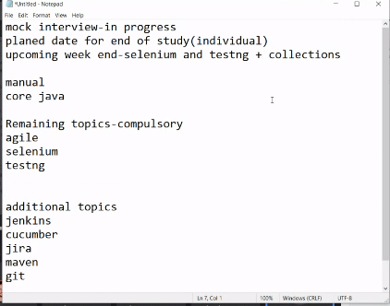

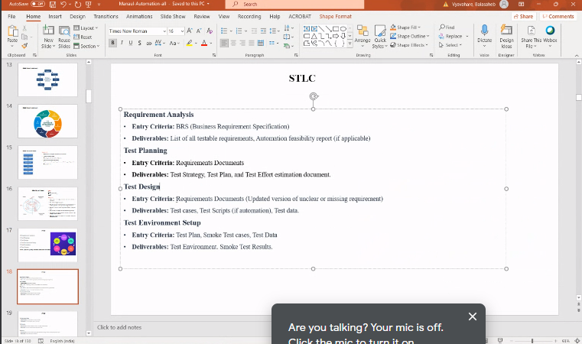

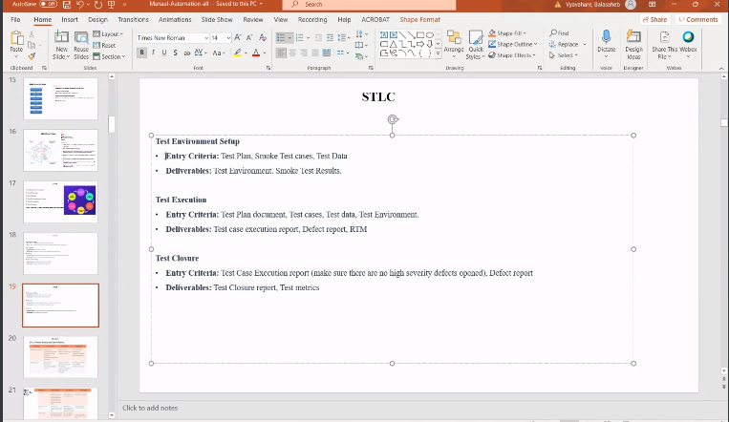

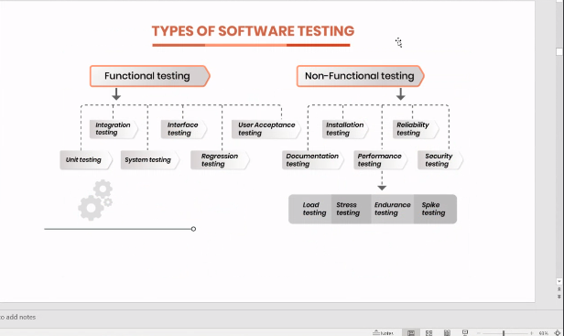

Very->static

Vali->dynamic

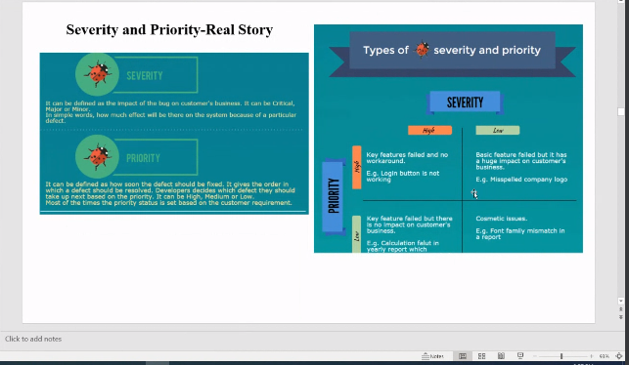

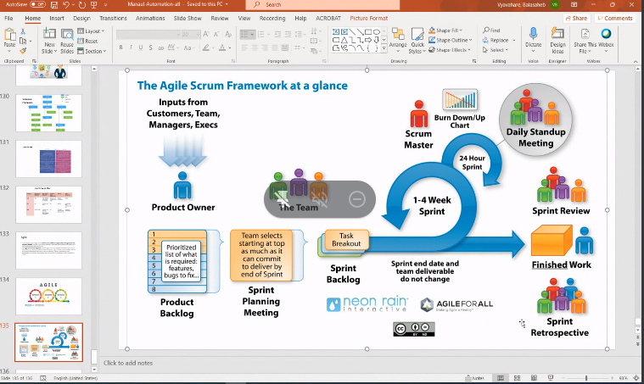

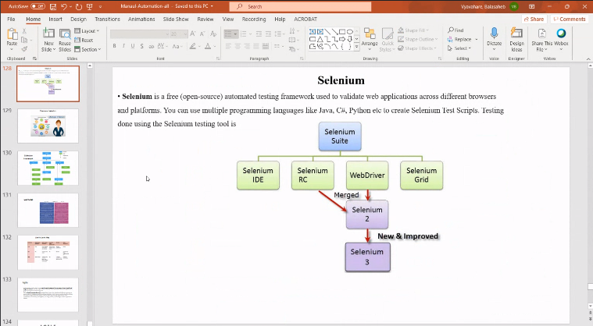

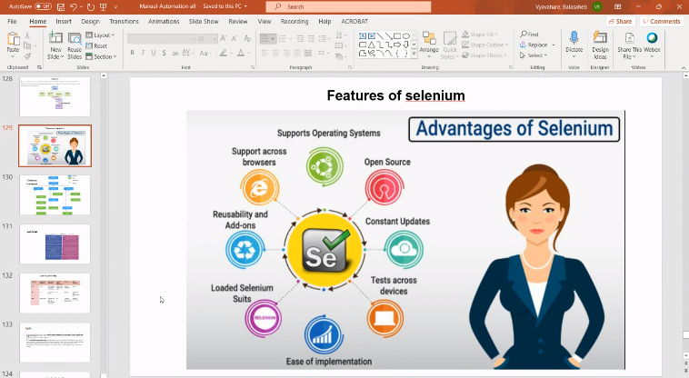

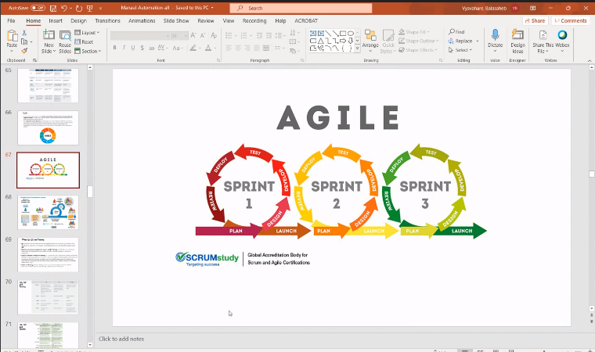

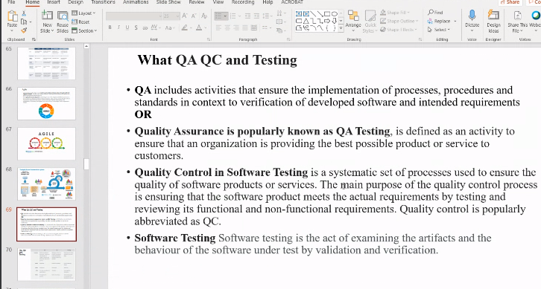

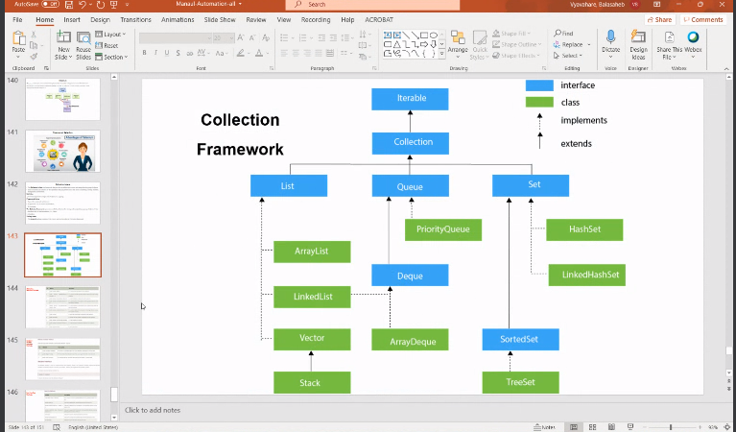

……….🡪implements dotted lines

---------🡪extends

